|  |  |  |  |
| --- | --- | --- | --- |
| Test Data | Reason | Expected Output | Actual Output |
| Width = 1000  Height = 800  Step = 100  Coord = null | This is the default setting. | There should be 5 horizontal and 4 vertical tick lines in the positive and negative. The coordinates should read (0,0) when no point selected. Tick markers should be placed at each grid line in increments of 100 | *Appendix 1* |
| Width = 600  Height = 600  Step = 50  Coord = (-300,-300) | These are the minimum grid settings and an edge point on the grid. | The grid should be square and have 6 grid lines in each direction. The marker should be in the bottom left on the edge of the grid The coordinates should read (-300,-300). | *Appendix 2* |
| Width = 2000  Height = 1000  Step = 200  Coord = (1000,-400) | These are the maximum grid settings and an edge point on the grid. | The grid width should be double the height. The vertical grind line should go past the vertical lines. The coordinate should sit on the edge the grid. | *Appendix 3* |
| Width = 1000  Height = 800  Step = 100  Coord = (520,420) | The clicked coordinate is outside the selectable area. | The coordinate should read (0,0) as its outside the grid parameters. | *Appendix 4* |
| Width = 1000  Height = 800  Step = 100  Coord = (-550,50) | The clicked coordinate is outside the selectable area. | The coordinate should read (0,0) as its outside the grid parameters. | *Appendix 5* |
| Width = 1000  Height = 800  Step = 100  Coord = (50,465) | The clicked coordinate is outside the selectable area. | The coordinate should read (0,0) as its outside the grid parameters. | *Appendix 6* |
| Width = 821  Height = 739  Step = 91  Coord = (91,91) | Less rounded grid parameters to test drawing of grid. Coordinates check grid line placement. |  | *Appendix 7* |
| Width = 888  Height = 888  Step = 88  Coord = (-264,264) | Less rounded grid parameters to test drawing of grid. Coordinates check grid line placement. |  | *Appendix 8* |
| Width = 677  Height = 919  Step = 59  Coord = (19,240) | The grid parameters are prime numbers and won’t be evenly divisible. |  | *Appendix 9* |
| Width = -1000  Height = 800  Step = 100  Coord = (0,0) | The width is outside range but the absolute is within. | An error should occur telling the user to try a different value. | *Appendix 10* |
| Width = 1000  Height = 1001  Step = 100  Coord = (0,0) | Thew height is above range. | An error should occur telling the user to try a different value. | *Appendix 11* |
| Width = 1000  Height = 800  Step = 0  Coord = (0,0) | The step is zero and may appear as a null value and is outside the required range. | An error should occur telling the user to try a different value. | *Appendix 12* |

## Appendix 1

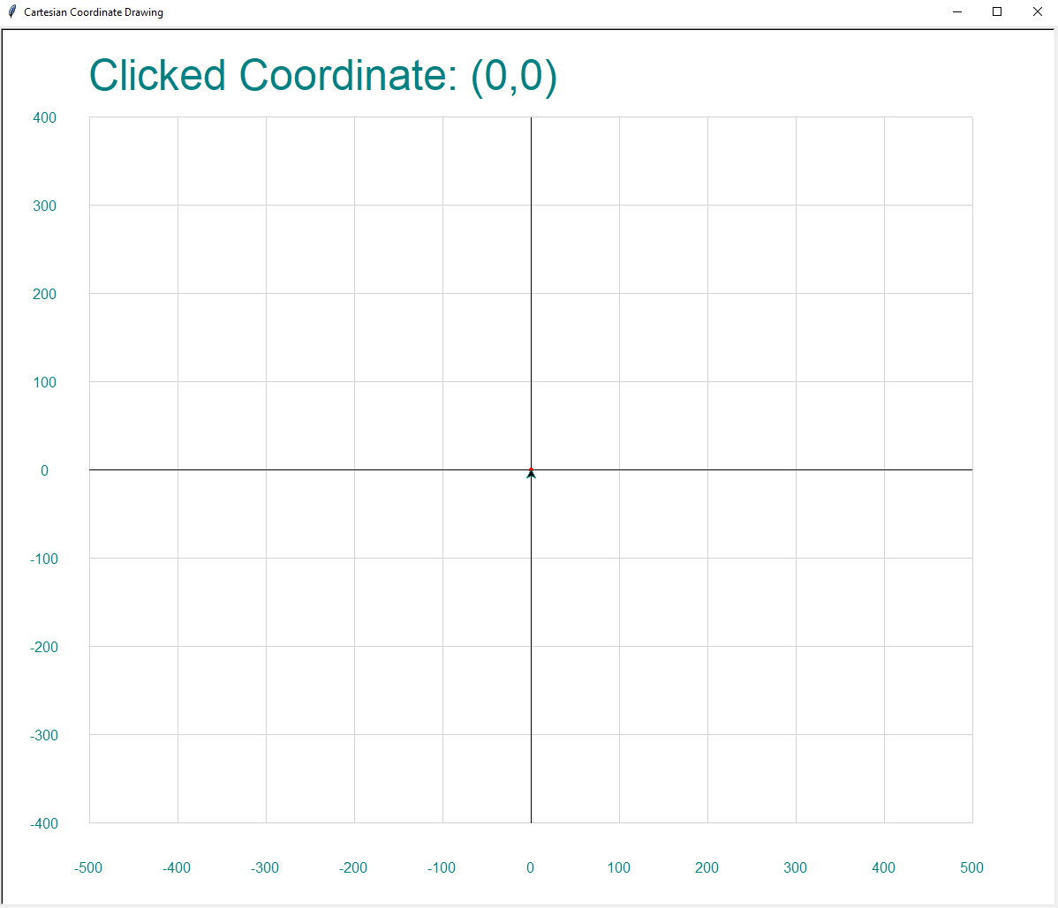

Appendix 2

## Appendix 3

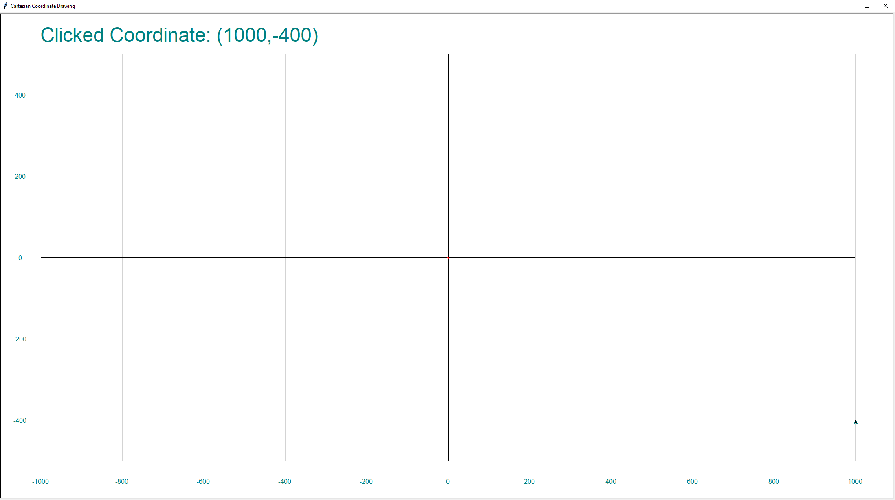

## Appendix 4

## Appendix 5

## Appendix 6

## Appendix 7

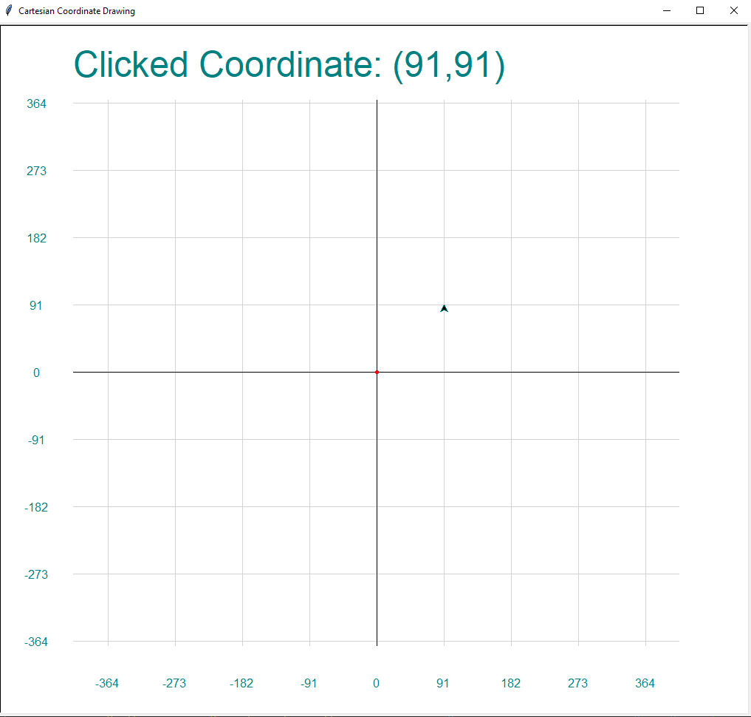

## Appendix 8

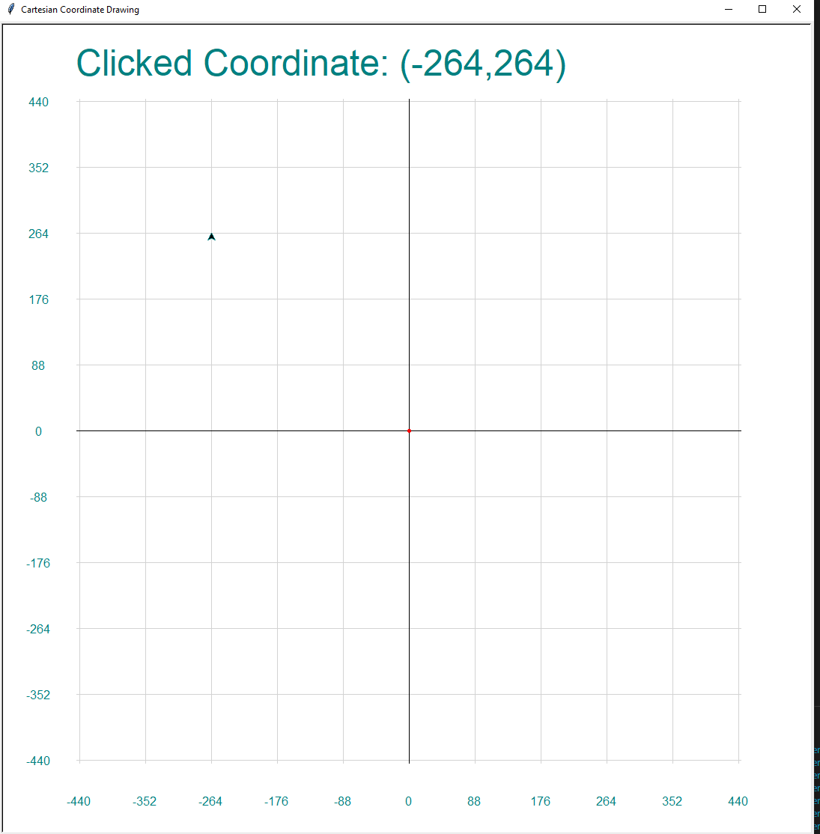

## Appendix 9

## 

## Appendix 10

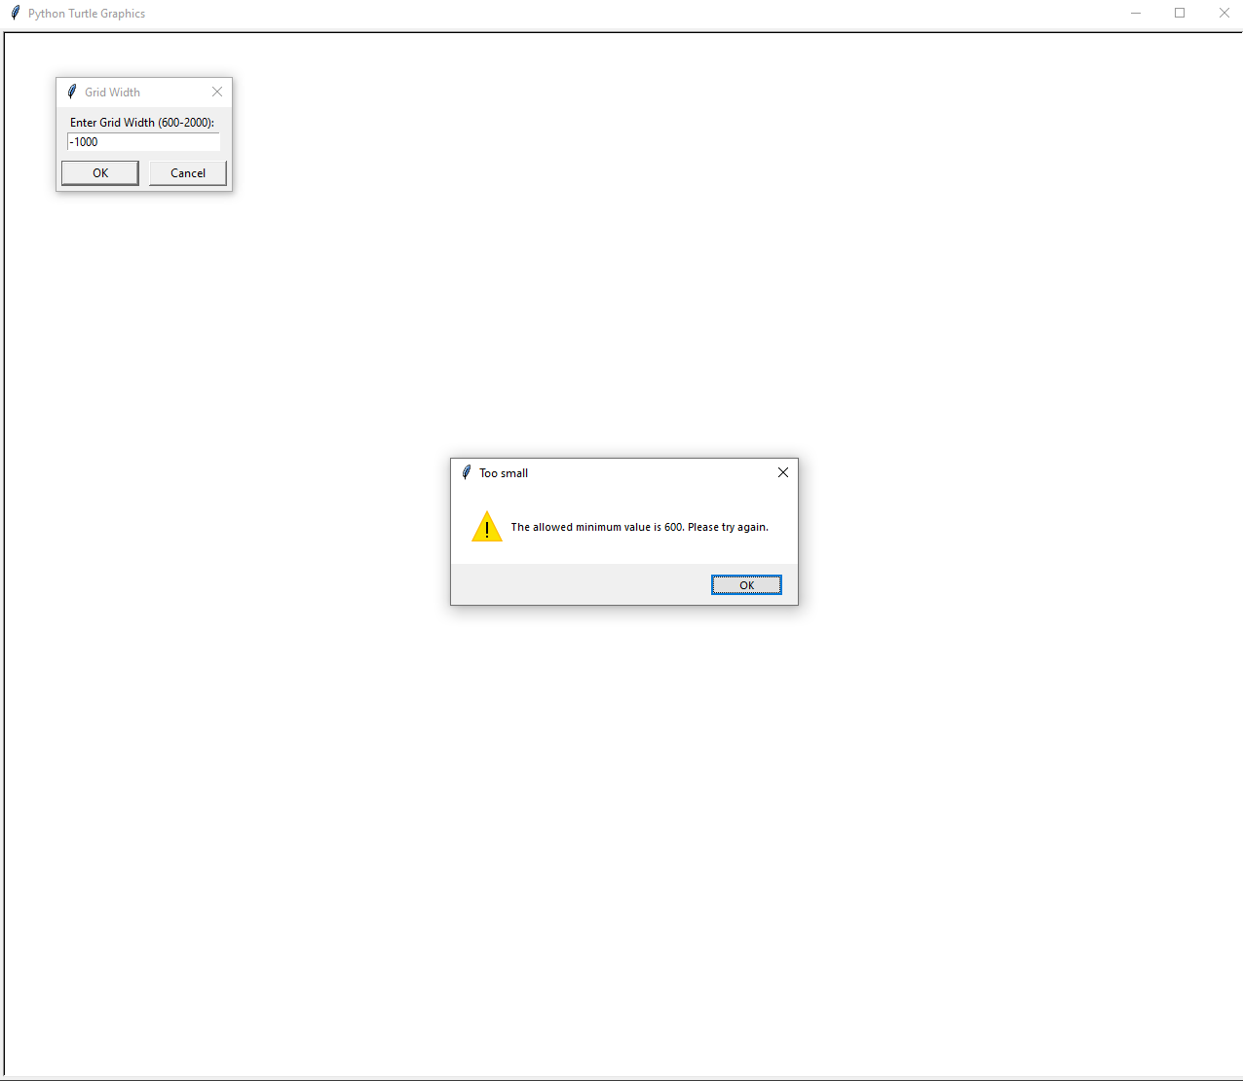

## Appendix 11

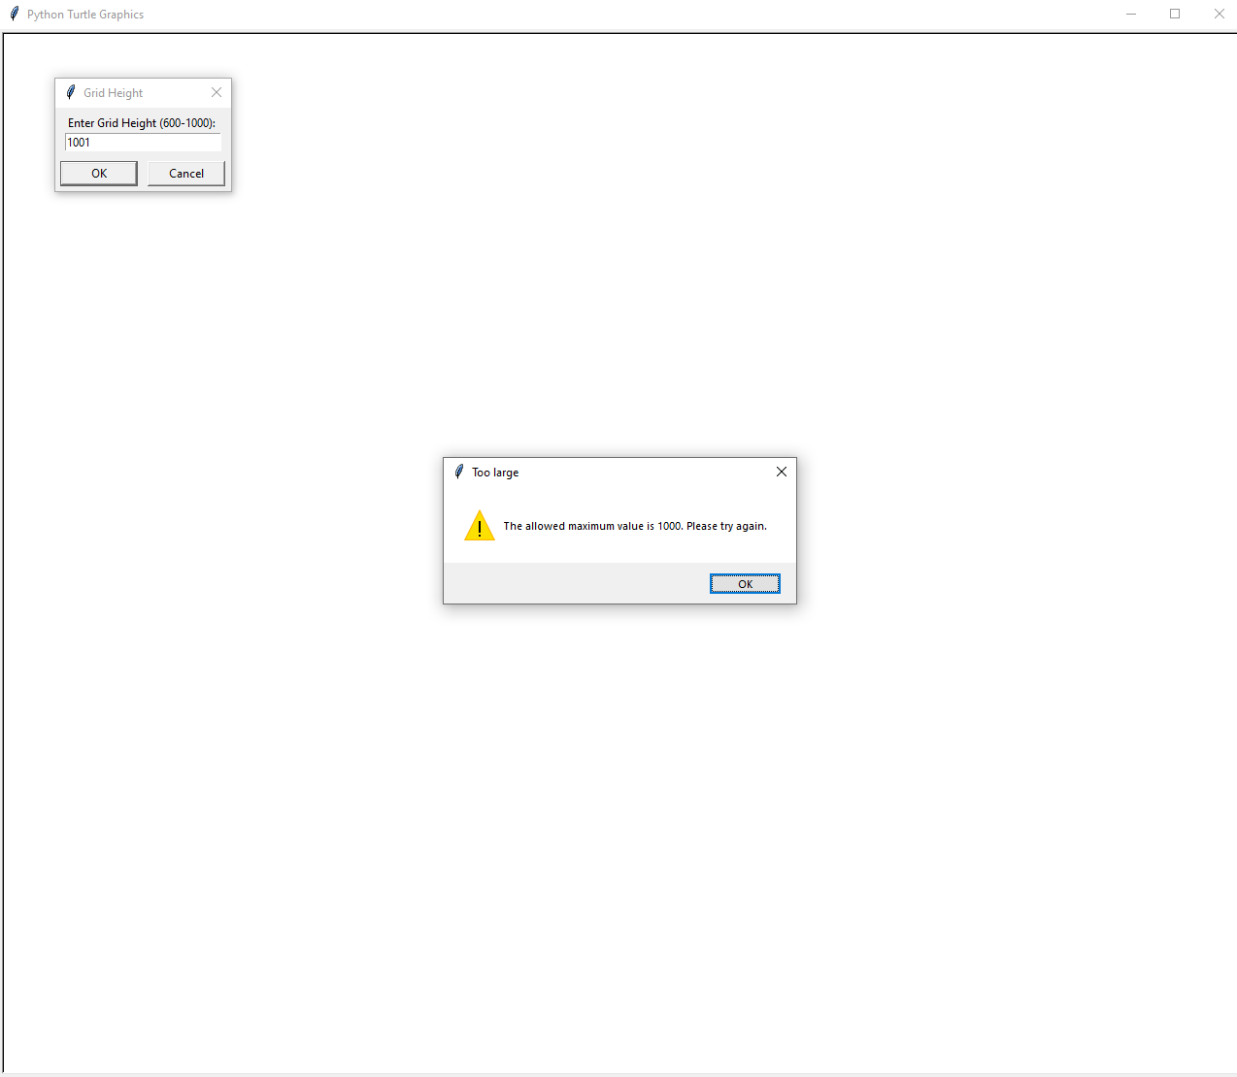

## Appendix 12

